Manuscript Number: JAEROSCI-D-20-00128

Heterogeneity in lobar and near-acini deposition of inhaled aerosol in the mouse lung

Dear Dr. Darquenne,

Thank you for submitting your manuscript to Journal of Aerosol Science.

I have completed my evaluation of your manuscript. The reviewers recommend reconsideration of your manuscript following minor revision and modification. I invite you to resubmit your manuscript after addressing the comments below. Please resubmit your revised manuscript by August 7, 2020.

When revising your manuscript, please consider the reviewers' comments carefully: please outline every change made in response to their comments and provide a reason for any comments not addressed. Please note that your revised submission may need to be re-reviewed.

To submit your revised manuscript, please log in as an author at <https://www.editorialmanager.com/jaerosci/>, and navigate to the "Submissions Needing Revision" folder under the Author Main Menu.

Journal of Aerosol Science values your contribution and I look forward to receiving your revised manuscript.￼

Kind regards,

Robert Phalen

Special Issue Managing Guest Editor

Journal of Aerosol Science

Editor and Reviewer comments:

Reviewer #1: This is a unique study in that using available measurements on particle deposition in the lungs of Balb/c mice, authors examined the hot spots (regions with high deposition). Findings of the study can aid in improved health risk assessment based on localized and not total dose of deposited particles in the lung. It can also inform drug delivery to targeted sites in the lung. The study is well done and this reviewer offers a few comments/suggestions to be addressed to improve the quality of the work.

It would be informative and help reader follow the manuscript if the manuscript includes a diagram of the mouse lung with each lobe indicated in the figure.

A figure identifying the different lobes of the mouse lung has been added to the manuscript in section 2.2.1.

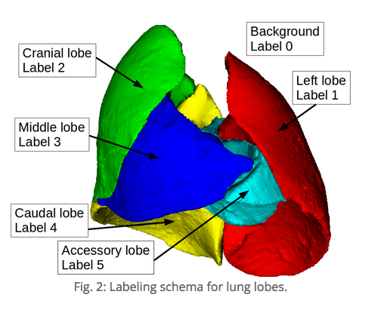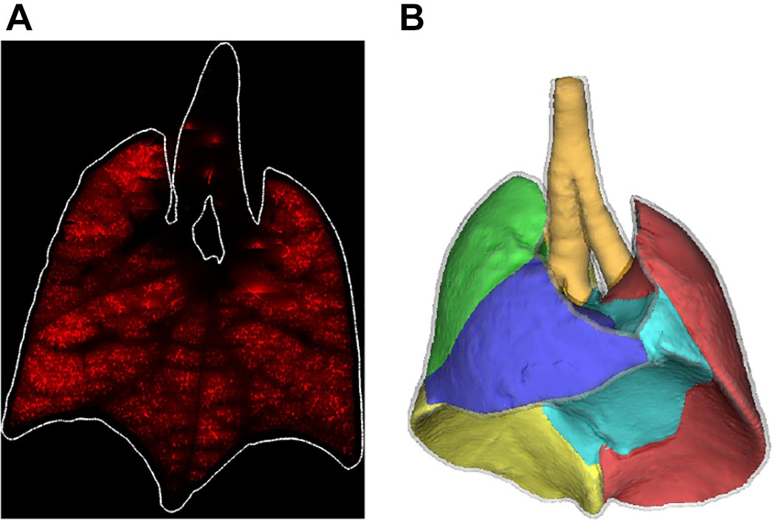

DVlobe depends on animal breathing rates and lung and lobar volumes. Were the data reported or calculated? Please report the information used in your calculations.

DVlobe was calculated as the ratio between lobar volume () normalized by total lung volume () and lobar deposition () normalized by total deposition (). All four variables, , , and were provided in the lapdMouse archive.

A new table summarizing animal lung volumes, tidal volumes and breathing rates is now included in section xxx.

It is noted that DVlobe can also be interpreted as volume-normalized lobar deposition (Dlobe/Vlobe)/(D/V). This definition helps with the interpretation of deposition distribution.

Please define particle deposition density. Is it the same as DVlobe? If deposition density is defined as D/V, the discussion in the paragraph before section 2.2.2 follows easier.

Particle deposition density, in the context of this paper, is equivalent to the DVlobe ratio.

Authors should examine an article that calculates DVlobes to be nearly unity in humans (Asgharian et al., 2004: Journal of Aerosol Science, 17:213-224). The study does not include statistical analysis to determine heterogeneity of deposition.

We assumed the reviewer referred to a paper in the Journal of Aerosol Medicine not in the Journal of Aerosol Science. Interestingly, Asgharian and colleagues showed in that paper that the ratio of lobar deposition to lobar volume was close to one in all lobes at all ages. This contrasts with the results in mice. The likely explanation for these differences is the presence of non-uniform specific ventilation in the lobes of the mouse lung but uniform specific ventilation in human lobes during tidal breathing, as modeled in Asgharian et al simulations. Indeed, in the methods section of their paper, Asgharian et al. state that “flow partitioning in each airway was proportional to the volume distal to the given airway”. By design, this flow partitioning results in a uniform ventilation of the lung. In contrast, in rodents, it has been previously shown experimentally that the cranial lobe is better ventilated (higher specific ventilation) than the other lobes (lower specific ventilation) (Rooney et al. (2009). No modification has been made to the manuscript on this comment.

Particle size distribution often follow lognormal distribution. Why isn't geometric standard deviations used in place standard deviation. Skewness can be calculated in a similar way.

While it is correct that the distribution of particle size of an aerosol usually follows a lognormal distribution, the particles used in this study were polystyrene particles with uniform size, i.e. monodisperse (0.5, 1 or 2 µm depending on the experimental conditions). The monodisperse polystyrene particles were aerosolized using a mesh nebulizer. The wet aerosol was then passed through a drying column, which resulted in a dry aerosol of uniform size to be delivered to the animals as described in the lapd archive (https://lapdmouse.iibi.uiowa.edu/AnimalModel/). The statistical distribution addressed in this paper deals with the distribution of particle deposition and not of particle size. Currently we are not aware that there are literature showing that the particle deposition follows lognormal instead of normal distribution. With that said, the distributions should be bounded by zero and skewed to the right due to the presence of hot spots. Furthermore, the distribution of deposited particles from imaging studies have typically been described with moment analysis of frequency distributions (see Garrard et al., 1981, but also Olseni et al., 1994, Fauroux et al., 2000, Darquenne et al, 2013, Bennett et al, 2015, 2018 to name a few studies). We followed the same approach in our study.

Figure 3: Define units for the x-axis.

The units for the x-axis are arbitrary, normalized based on individual mice. The abbreviation is now defined in the figure legend.

First line after Figure 4: Change "size" to "sizes".

Done.

The paragraph before Figure 5: The discussion appears to apply to humans and not to mice. Better ventilation of apical lobes in humans is the effect of pleural pressure distribution, which is established by the gravity. In rats, lung expansion is expected to be uniform among different lobes because of animal's position. In humans, apical lobes have lower volume (and receive lower flows). I suggest authors compare lobar volumes in rats to confirm the explanation for higher impaction deposition in cranial lobes. Another point to make is that impaction deposition is significant in the first few airway generations of the lung. Flow in the near acini airways is low and impaction does not seem to be a viable deposition mechanism. For particle sizes of this study, it is likely due to sedimentation.

As described in our response above, it has been experimentally shown that in rodents, the cranial lobe is better ventilated than the other lobes (Rooney et al. (2009). Thus, the cranial lobe receives during each inhalation a higher fraction of particles than the other lobes do based on their volume. This likely leads to higher deposition per unit volume in the better ventilated lobes. We agree with the reviewer that, because of the size of the mouse lung, gravity is unlikely to play a significant role in the ventilation distribution among the lobes. We have added references in the paragraph before Figure 5 and clarify statements related to ventilation in rodents.

Reviewer #2: This is a very nicely presented study using a recently published database of Mouse lung anatomy and aerosol deposition.  It includes many more animals than in prior studies and explores the effects of sex and strain on observed patterns of aerosol deposition.  The authors find that aerosols with diameters ranging from 0.5 - 2.0 µm consistently deposit to a greater degree in the right cranial lobe.

Major Comments

1) Multiple t-tests performed raise a few issues that should be addressed.  Should the p-value chosen for significance be corrected for multiple comparisons as is commonly done with the Bonferroni correction.  Because the measures of aerosol deposition are relative to each other, they are not independent of each other.  If one lobe has a high deposition, another lobe must have a lower deposition.  I suspect that this non-independence needs to be considered in the statistical analyses.

Corrected p values are now included in the manuscript based on Bonferroni correction. All results are still significant at the level of 0.05.

2) I am confused by the description of the apex-to-base distribution analyses.  The authors state that each near-acini compartment location was determined by its distance to a reference plane that intersects with the carina and is perpendicular to the bisector line between the main bronchi.  I envision this as a transverse plane (traditional CT slice) that is at the level of the carina.  Hence a compartment in the cranial lung region might have the same distance as a compartment in the basal lung region.  The data in figure 5 show compartments with distances of up to 20 mm from the carina.  This seems to be a large distance for a mouse lung if only being measured from the carina.  The data in figure 5 appear to be plotted as a function of location along the cranial to caudal direction rather than the distance from the carina.

The distance was indeed measured from a specific location. The location of the reference plane was defined as including the intersection of the centerlines of the trachea and main bronchi, which would be slightly higher than the carina itself. In all but 5 mice, the centroid of all near acini compartments were located below the reference plane. Compartment located above the reference plane were assigned a negative value. We agree that using the term “carina” to define this point was a little loose. We have modified the text to better describe the location of the reference plane.

Regarding the lung size, a distance of up to 20 mm in the cranial to caudal direction is typical for mice of ~25g when lungs are inflated to TLC. To illustrate this, we have included below a picture of a lung inflated to a pressure of 25 cm H2O from a 23 g mouse from a study currently ongoing in our lab (see below). The picture was taken in front of graph paper (grid spacing = 1 mm) and show that a distance of 20 mm is a reasonable measure at TLC. For comparison, the weight of the mice included in the lapdMouse archive is 23 ± 1.7 g.

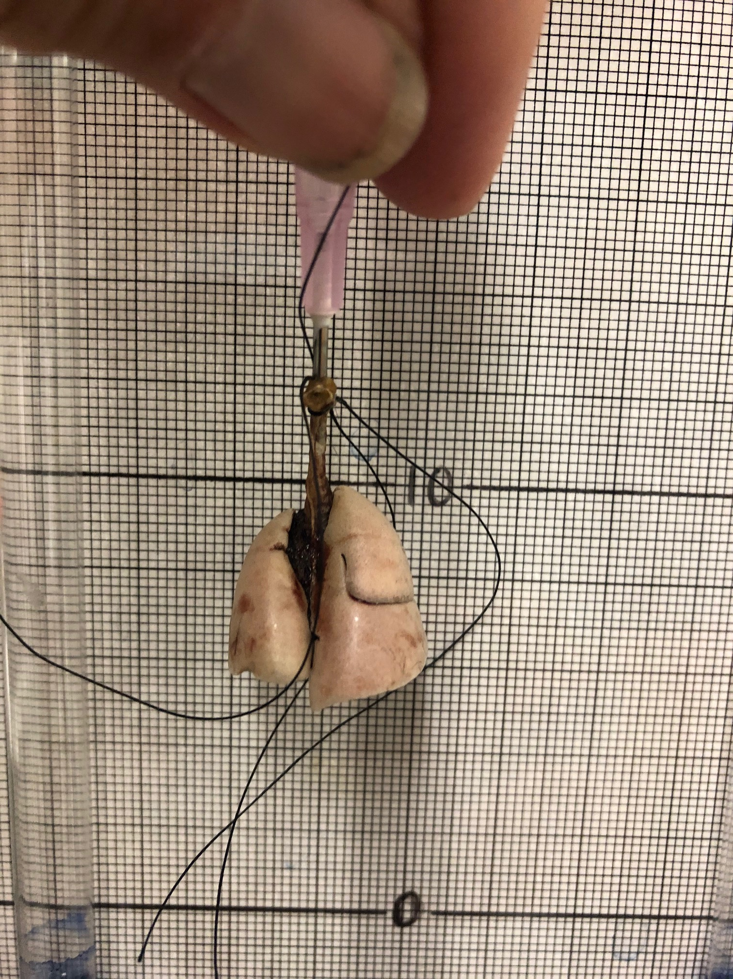

3)  I have a tough time deciphering the legends in figure 2.  There appears to be 2 mouse studies (triangles) that are both black (this study).  The triangles indicating mice C57BL/6 suggest that only that strain was used in the figure but I do not get that from reading the text.  The text has C57J/6 mice while the legend has C57BL/6 mice.  Rather than using shades of grey to indicate the study, might the authors use solid markers, open markers, and dotted marker/lines?

Figure 2 has been updated.

4) Why were the 0.5 particles not included in figure 2B?

Data with 0.5 µm particles were obtained in Balb/c mice. Only data from C57BL/6 mice were included in figure 2B and as such no 0.5 µm data sets from the lapdMouse archive were included. We have now make this clearer in the legend and in the text.

5) The authors state a significant effect of "height" on the deposition pattern with deposition being greater in the lung apex.  In a prone mouse, the lung apex is at the same level as the lung base so I do not see the effect of height.  The authors later discuss non-dependent and dependent lung regions when they are talking about cranial and caudal regions, respectively.  Again, I do not think of these as non-dependent and dependent regions in a prone mouse.

We have modified the wording and refrain to use “height” to describe the position of the near-acini compartments to avoid the analogy with gravitational effects and height. Similarly, we now refer to the cranial and caudal regions of the lung rather than apex and base of the lung. Changes have been made throughout the manuscript.

6) The authors define "hot spots" within near-acini regions.  They then suggest that the hot spots are likely at airway bifurcations to the apical lung regions.  If I understand it correctly, the defined hot spots are in the near-acini compartments exclude the airways and therefore cannot be at airway bifurcations.

The figure below (Fig 14 from bauer et al. *J. Appl. Physiol.*, 2020) shows the near-acini segmentation (panel B) and the segmented airways (panel D). All distal airways identified in red in panel D were included in the near-acini compartments. The only airways excluded from the near-acini segmentations were the main monopodial airways leading to each lobe. So, deposition at each airway bifurcation was included in the near-acini deposition analysis, except So, except for deposition at the most proximal airway bifurcation in each lobe.

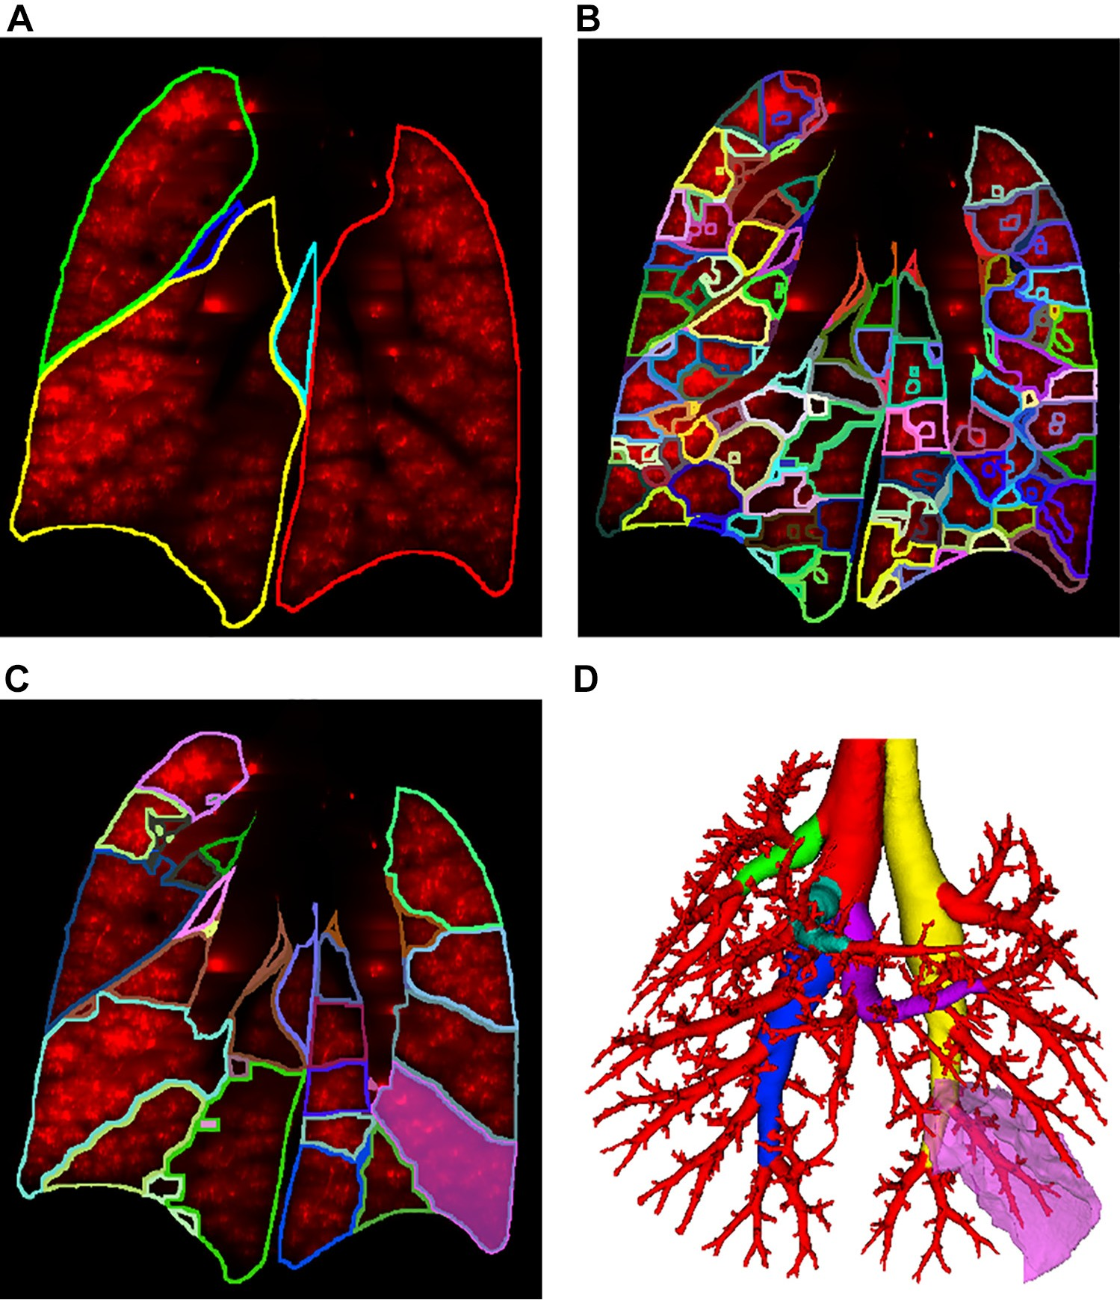

7)  Because the hot spots are defined as deposition greater than 2.3 standard deviations above the median, they are going to be much more likely to be present in regions of higher aerosol deposition.  Couldn't these hot spots simply be an accumulation of aerosols in highly ventilated lung regions.  The question is why do the cranial lung regions have a higher specific ventilation than other lung regions.  Traditionally it is thought that specific ventilation is greater in a lung region because either it is more compliant or has a greater transpulmonary pressure than other regions.  Obviously in a prone mouse, this cannot be gravity related.

We agree that higher deposition is likely to occur in highly ventilated lung regions. However, if deposition was mainly due gravitational sedimentation, one would expect deposition to be more uniformly distributed in the highly ventilated regions. Regarding specific ventilation, we agree that, because of the size of the mouse lung, gravity is unlikely to play a significant role in the ventilation distribution among the lobes. Indeed, Rooney et al (2009) showed that gravity had little impact on regional filling of the lungs of small rodents but rather that regional filling characteristics were mainly dependent on anatomy. Text has been edited in page xxx.

Minor Comments

1) Abstract, last line - suggest adding "…depending on the lung sample location…"

Done

2) Suggest table 1 present the numbers of animals analyzed in this study rather than the numbers in the database.

Done (remove balb/c 2 µm Female)

3) Last sentence in 2.2.2 should be "… and their spatial locations were recorded."

Corrected

4) "Data showed in Figure 1 …" should be "Data shown in Figure 1…" 9page 10, line 4).

Corrected

5) In general, cranial and caudal are better anatomical descriptors than apex and base, respectively.

We have replaced apex and base with cranial and caudal throughout the manuscript.

\*\*\*\*\*

Data in Brief (optional):

We invite you to convert your supplementary data (or a part of it) into an additional journal publication in Data in Brief, a multi-disciplinary open access journal. Data in Brief articles are a fantastic way to describe supplementary data and associated metadata, or full raw datasets deposited in an external repository, which are otherwise unnoticed. A Data in Brief article (which will be reviewed, formatted, indexed, and given a DOI) will make your data easier to find, reproduce, and cite.

You can submit to Data in Brief when you upload your revised manuscript. To do so, complete the template and follow the co-submission instructions found here: www.elsevier.com/dib-template. If your manuscript is accepted, your Data in Brief submission will automatically be transferred to Data in Brief for editorial review and publication.

Please note: an open access Article Publication Charge (APC) is payable by the author or research funder to cover the costs associated with publication in Data in Brief and ensure your data article is immediately and permanently free to access by all. For the current APC see: www.elsevier.com/journals/data-in-brief/2352-3409/open-access-journal

Please contact the Data in Brief editorial office at [dib-me@elsevier.com](mailto:dib-me@elsevier.com) or visit the Data in Brief homepage (www.journals.elsevier.com/data-in-brief/) if you have questions or need further information.

\*\*\*\*\*

MethodsX (optional)

We invite you to submit a method article alongside your research article. This is an opportunity to get full credit for the time and money spent on developing research methods, and to increase the visibility and impact of your work. If your research article is accepted, we will contact you with instructions on the submission process for your method article to MethodsX. On receipt at MethodsX it will be editorially reviewed and, upon acceptance, published as a separate method article. Your articles will be linked on ScienceDirect.

Please prepare your paper using the MethodsX Guide for Authors: <https://www.elsevier.com/journals/methodsx/2215-0161/guide-for-authors> (and template available here: <https://www.elsevier.com/MethodsX-template>) Open access fees apply.

More information and support

FAQ: How do I revise my submission in Editorial Manager?